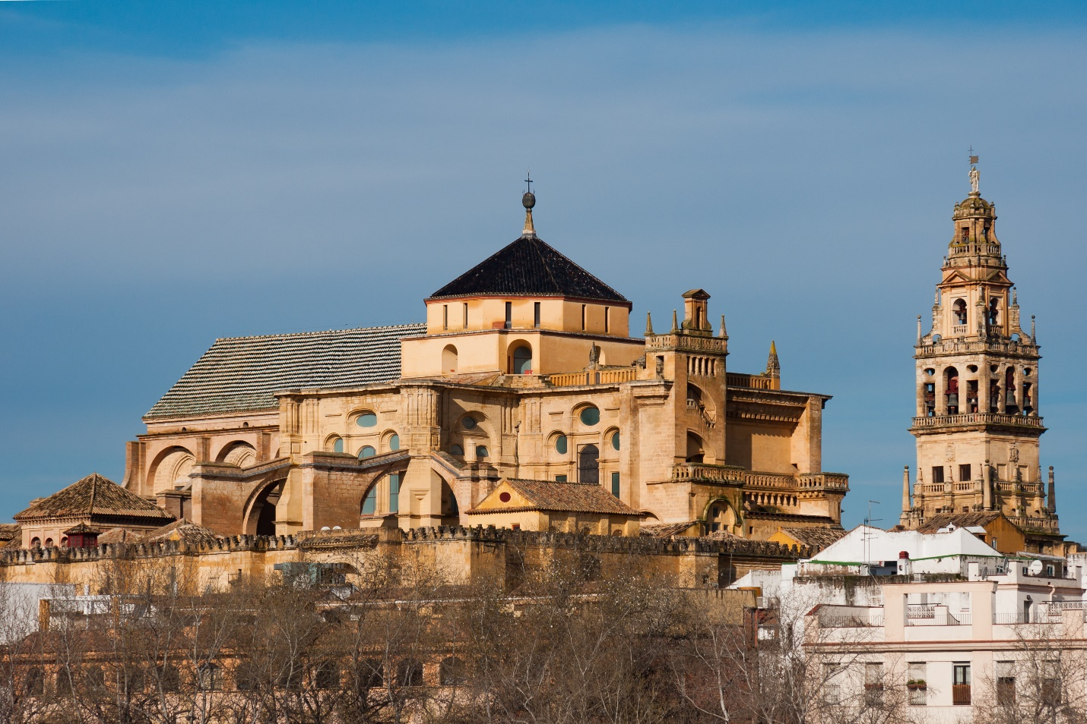

# Mosque–Cathedral of Córdoba

The **Mosque–Cathedral of Córdoba**[[1]](https://en.wikipedia.org/wiki/Mosque%E2%80%93Cathedral_of_C%C3%B3rdoba#cite_note-1)[[2]](https://en.wikipedia.org/wiki/Mosque%E2%80%93Cathedral_of_C%C3%B3rdoba#cite_note-britannica-2) ([Spanish](https://en.wikipedia.org/wiki/Spanish_language): *Mezquita-Catedral de Córdoba* [[meθˈkita kateˈðɾal de ˈkoɾðoβa]](https://en.wikipedia.org/wiki/Help:IPA/Spanish)), officially known by its [ecclesiastical](https://en.wikipedia.org/wiki/Ecclesiastical) name of **Cathedral of Our Lady of the Assumption** (Spanish: *Catedral de Nuestra Señora de la Asunción*),[[3]](https://en.wikipedia.org/wiki/Mosque%E2%80%93Cathedral_of_C%C3%B3rdoba#cite_note-3) is the [cathedral](https://en.wikipedia.org/wiki/Cathedral) of the [Diocese of Córdoba](https://en.wikipedia.org/wiki/Roman_Catholic_Diocese_of_C%C3%B3rdoba) dedicated to the [Assumption of Mary](https://en.wikipedia.org/wiki/Assumption_of_Mary) and located in the Spanish region of [Andalusia](https://en.wikipedia.org/wiki/Andalusia).[[4]](https://en.wikipedia.org/wiki/Mosque%E2%80%93Cathedral_of_C%C3%B3rdoba#cite_note-Daniel2013-4) Due to its status as a former [mosque](https://en.wikipedia.org/wiki/Mosque), it is also known as the **Mezquita** (Spanish for 'mosque')[[5]](https://en.wikipedia.org/wiki/Mosque%E2%80%93Cathedral_of_C%C3%B3rdoba#cite_note-Petersen2002-5)[[6]](https://en.wikipedia.org/wiki/Mosque%E2%80%93Cathedral_of_C%C3%B3rdoba#cite_note-CunninghamReich2016-6) and as the **Great Mosque of Córdoba**.[[7]](https://en.wikipedia.org/wiki/Mosque%E2%80%93Cathedral_of_C%C3%B3rdoba#cite_note-unesco-7)[[2]](https://en.wikipedia.org/wiki/Mosque%E2%80%93Cathedral_of_C%C3%B3rdoba#cite_note-britannica-2)[[8]](https://en.wikipedia.org/wiki/Mosque%E2%80%93Cathedral_of_C%C3%B3rdoba#cite_note-8)

According to traditional accounts a [Visigothic](https://en.wikipedia.org/wiki/Visigothic_Kingdom" \o "Visigothic Kingdom) church, the [Catholic](https://en.wikipedia.org/wiki/Catholic_Church) Christian [Basilica](https://en.wikipedia.org/wiki/Basilica) of [Vincent of Saragossa](https://en.wikipedia.org/wiki/Vincent_of_Saragossa), originally stood on the site of the current Mosque-Cathedral, although this has been a matter of scholarly debate.[[9]](https://en.wikipedia.org/wiki/Mosque%E2%80%93Cathedral_of_C%C3%B3rdoba#cite_note-grove-9)[[10]](https://en.wikipedia.org/wiki/Mosque%E2%80%93Cathedral_of_C%C3%B3rdoba#cite_note-khoury-10) The Great Mosque was constructed in 785 on the orders of [Abd al-Rahman I](https://en.wikipedia.org/wiki/Abd_al-Rahman_I" \o "Abd al-Rahman I), founder of the Islamic [Emirate of Córdoba](https://en.wikipedia.org/wiki/Emirate_of_C%C3%B3rdoba).[[11]](https://en.wikipedia.org/wiki/Mosque%E2%80%93Cathedral_of_C%C3%B3rdoba#cite_note-:02-11)[[12]](https://en.wikipedia.org/wiki/Mosque%E2%80%93Cathedral_of_C%C3%B3rdoba#cite_note-:0-12)[[13]](https://en.wikipedia.org/wiki/Mosque%E2%80%93Cathedral_of_C%C3%B3rdoba#cite_note-:4-13)[[14]](https://en.wikipedia.org/wiki/Mosque%E2%80%93Cathedral_of_C%C3%B3rdoba#cite_note-:24-14) It was expanded multiple times afterwards under Abd al-Rahman's successors up to the late 10th century. Among the most notable additions, [Abd al-Rahman III](https://en.wikipedia.org/wiki/Abd_al-Rahman_III" \o "Abd al-Rahman III) added a [minaret](https://en.wikipedia.org/wiki/Minaret) (finished in 958) and his son [al-Hakam II](https://en.wikipedia.org/wiki/Al-Hakam_II) added a richly-decorated new *[mihrab](https://en.wikipedia.org/wiki/Mihrab" \o "Mihrab)* and *[maqsurah](https://en.wikipedia.org/wiki/Maqsurah" \o "Maqsurah)* section (finished in 971).[[15]](https://en.wikipedia.org/wiki/Mosque%E2%80%93Cathedral_of_C%C3%B3rdoba#cite_note-:1-15)[[12]](https://en.wikipedia.org/wiki/Mosque%E2%80%93Cathedral_of_C%C3%B3rdoba#cite_note-:0-12) The mosque was [converted to a cathedral](https://en.wikipedia.org/wiki/Conversion_of_mosques_into_non-Islamic_places_of_worship) in 1236 when Córdoba was [captured](https://en.wikipedia.org/wiki/Siege_of_C%C3%B3rdoba_(1236)) by the Christian forces of [Castile](https://en.wikipedia.org/wiki/Crown_of_Castile) during the [*Reconquista*](https://en.wikipedia.org/wiki/Reconquista). The structure itself underwent only minor modifications until a major building project in the 16th century inserted a new [Renaissance](https://en.wikipedia.org/wiki/Renaissance) cathedral [nave](https://en.wikipedia.org/wiki/Nave) and [transept](https://en.wikipedia.org/wiki/Transept) into the center of the building. The former minaret, which had been converted to a [bell tower](https://en.wikipedia.org/wiki/Bell_tower), was also significantly remodelled around this time. Starting in the 19th century, modern restorations have in turn led to the recovery and study of some of the building's Islamic-era elements.[[16]](https://en.wikipedia.org/wiki/Mosque%E2%80%93Cathedral_of_C%C3%B3rdoba#cite_note-:7-16)[[17]](https://en.wikipedia.org/wiki/Mosque%E2%80%93Cathedral_of_C%C3%B3rdoba#cite_note-:82-17) Today, the building continues to serve as the city's cathedral and [Mass](https://en.wikipedia.org/wiki/Mass_(liturgy)) is celebrated there daily.[[18]](https://en.wikipedia.org/wiki/Mosque%E2%80%93Cathedral_of_C%C3%B3rdoba#cite_note-Armstrong2013-18)

The mosque structure is an important monument in the history of [Islamic architecture](https://en.wikipedia.org/wiki/Islamic_architecture) and was highly influential on the subsequent ["Moorish" architecture](https://en.wikipedia.org/wiki/Moorish_architecture) of the western [Mediterranean](https://en.wikipedia.org/wiki/Mediterranean_Sea) regions of the [Muslim world](https://en.wikipedia.org/wiki/Muslim_world). It is also one of Spain's major [historic monuments](https://en.wikipedia.org/wiki/National_monuments_of_Spain) and tourist attractions,[[19]](https://en.wikipedia.org/wiki/Mosque%E2%80%93Cathedral_of_C%C3%B3rdoba#cite_note-19) as well as a [UNESCO](https://en.wikipedia.org/wiki/UNESCO) [World Heritage Site](https://en.wikipedia.org/wiki/World_Heritage_Site) since 1984.[[20]](https://en.wikipedia.org/wiki/Mosque%E2%80%93Cathedral_of_C%C3%B3rdoba#cite_note-20)

## **History**

A claim that the site of the mosque-cathedral was once a [Roman temple](https://en.wikipedia.org/wiki/Roman_temple) dedicated to [Janus](https://en.wikipedia.org/wiki/Janus) dates as far back as [Pablo de Céspedes](https://en.wikipedia.org/wiki/Pablo_de_C%C3%A9spedes)[[21]](https://en.wikipedia.org/wiki/Mosque%E2%80%93Cathedral_of_C%C3%B3rdoba#cite_note-21)[[22]](https://en.wikipedia.org/wiki/Mosque%E2%80%93Cathedral_of_C%C3%B3rdoba#cite_note-:20-22) and is sometimes still repeated today.[[23]](https://en.wikipedia.org/wiki/Mosque%E2%80%93Cathedral_of_C%C3%B3rdoba#cite_note-23)[[24]](https://en.wikipedia.org/wiki/Mosque%E2%80%93Cathedral_of_C%C3%B3rdoba#cite_note-24)[[25]](https://en.wikipedia.org/wiki/Mosque%E2%80%93Cathedral_of_C%C3%B3rdoba#cite_note-25) However, [Robert Knapp](https://en.wikipedia.org/wiki/Robert_Knapp_(classicist)), in his overview of Roman-era Córdoba, has dismissed this claim as speculation based on a misunderstanding of Roman [milestones](https://en.wikipedia.org/wiki/Milestone) found in the area.